

**Placement Empowerment Program**

***Cloud Computing and DevOps Centre***

**Implement DNS for Your Application:** Set up a DNS record to map your web application’s IP or load balancer to a domain name.

Name: Harivasan S

Department : ADS

**Introduction :**

**The Domain Name System (DNS) plays a vital role in web applications by translating human-friendly domain names (e.g.,** [**www.example.com**](http://www.example.com)**) into numerical IP addresses that machines can understand. This simplifies access to websites, eliminating the need to memorize complex IP addresses and improving user experience.**

**Objectives:**

**1.Configure a DNS record through a cloud-based DNS service, such as AWS Route 53.**

**2.Associate your web application's IP address or Load Balancer with a domain name.**

**3.Confirm and test DNS resolution by opening the domain in a web browser.**

**Step by Step Overview:**

**Step 1:**

**Create an EC2 instance**

- log into your aws account.

- create an EC2 instance.

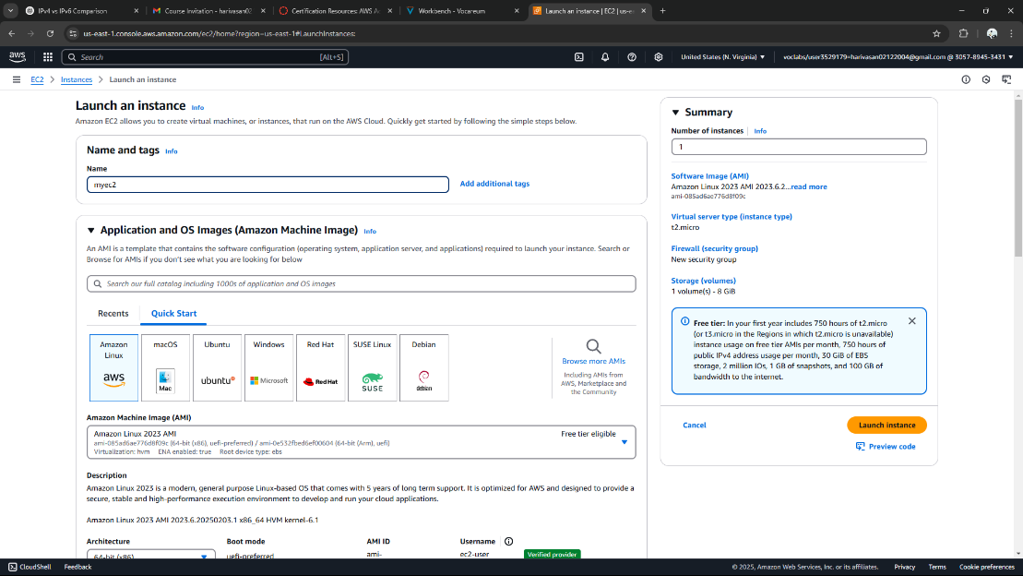

**Step 2:**

**Open the EC2 dashboard**

Find your instance and copy the Public IPv4 Address.

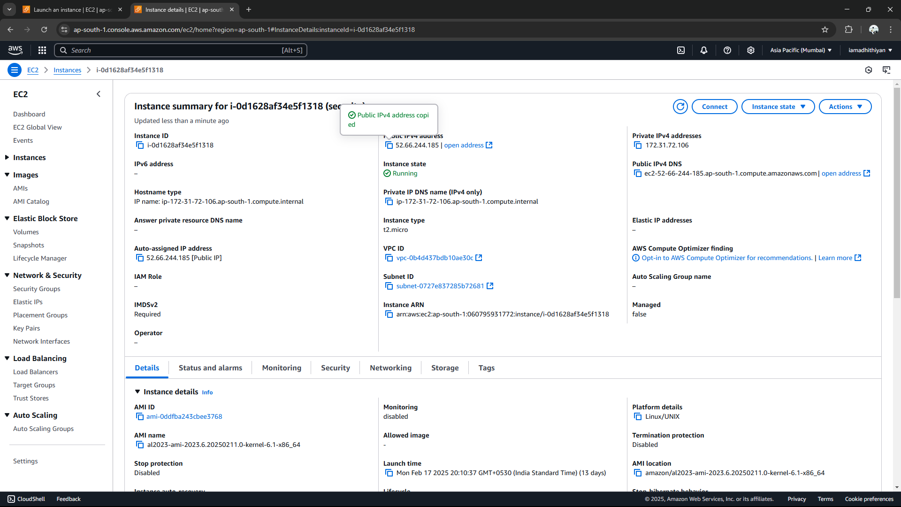

### **Step 3:**

### **Register a domain name**

- Open Amazon Route53

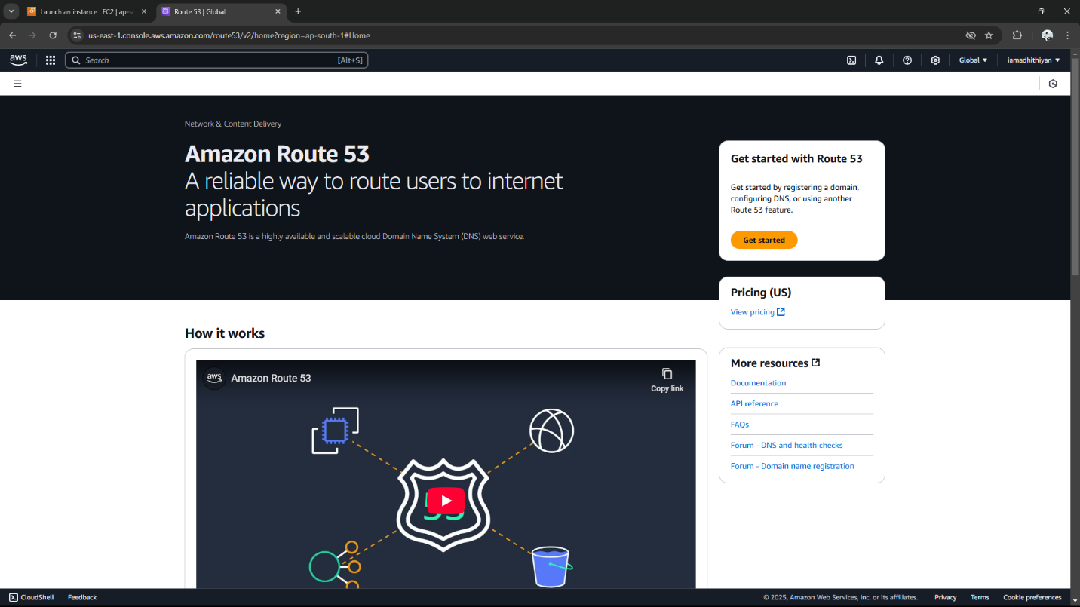

* Click **Register Domain** and follow the steps to purchase a domain.

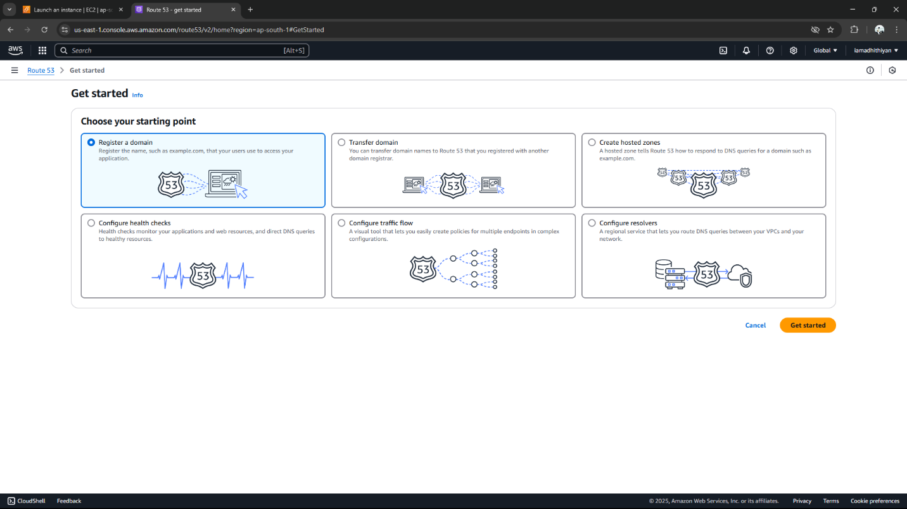

* Now you have successfully registered a Domain. (it might take a few minutes)

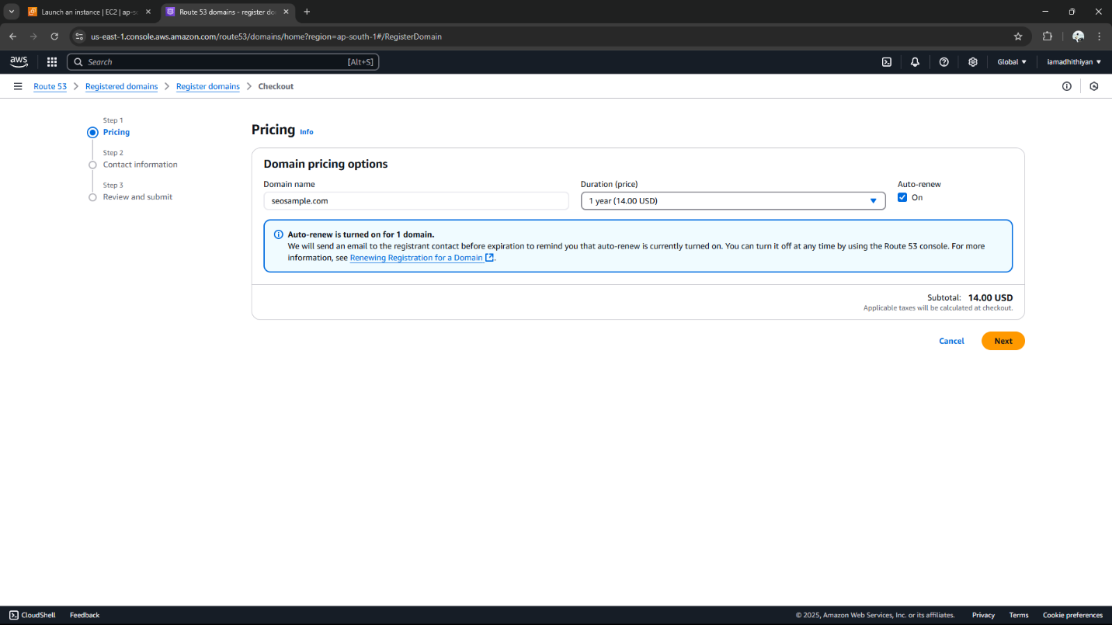

**Step 4:**

**Hosted Zone**

When you register the domain, AWS automatically creates a host zone.

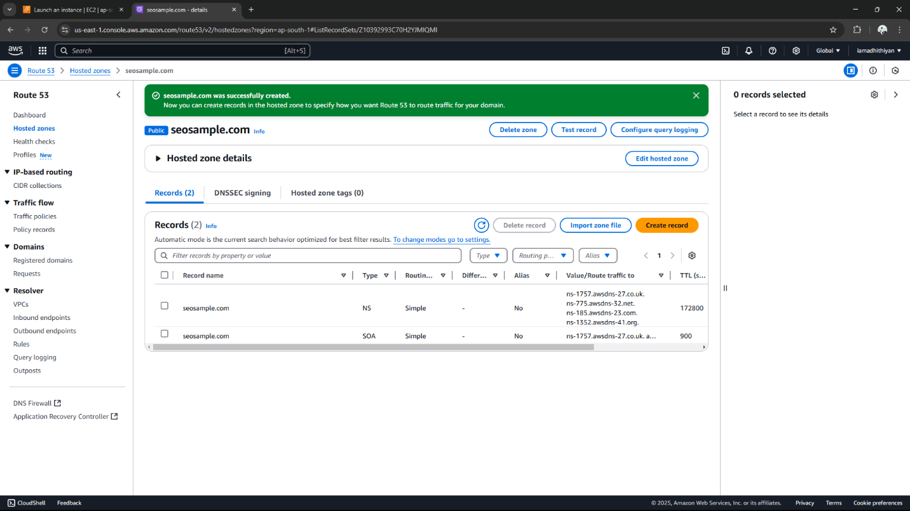

**Step 5:**

* Click "Create Record."
* Select Simple Routing and click "Next."
* Configure the record with the following details:
  + Record Name: Leave blank for the root domain (example.com) or enter "www" for [www.example.com](http://www.example.com).
  + Record Type: Select A – IPv4 Address.
  + Value: Enter your EC2 Public IPv4 Address (e.g., 3.123.45.67).
  + TTL: Use the default setting (300 seconds).
* Click "Create Record."

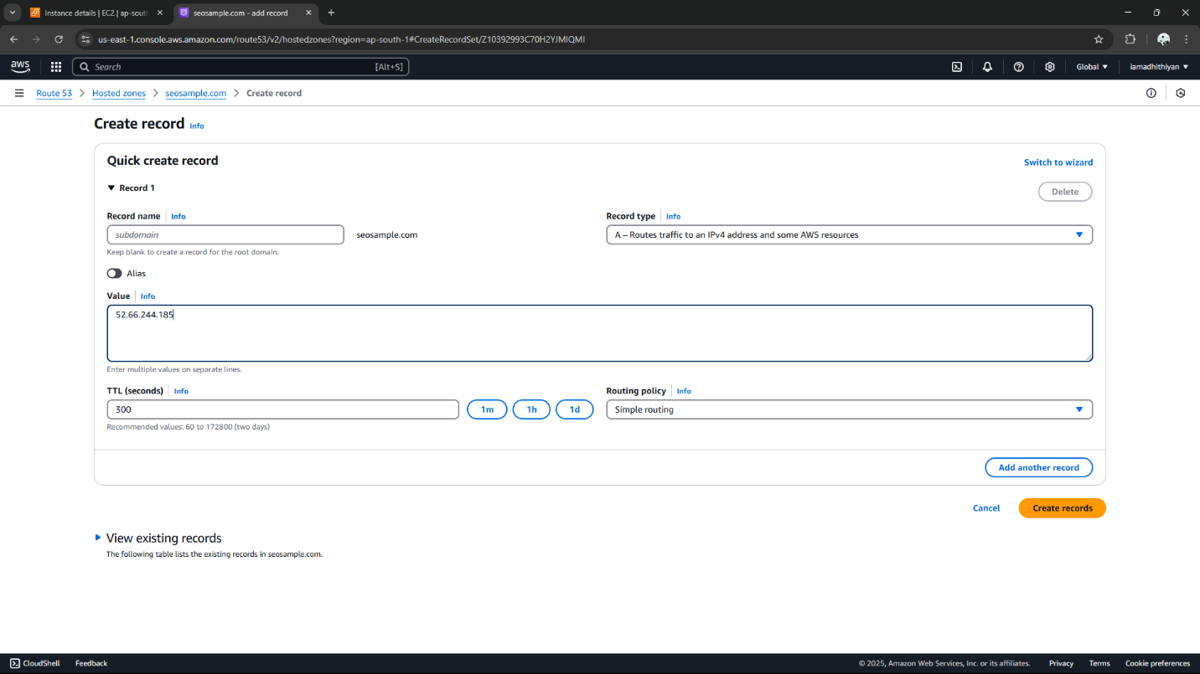

**Step 6:**

**Verify the Domain**

Wait a few minutes, then test if the domain resolves correctly.

Using **nslookup <domainname.com>** - you can test the configurations of your EC2 instance.

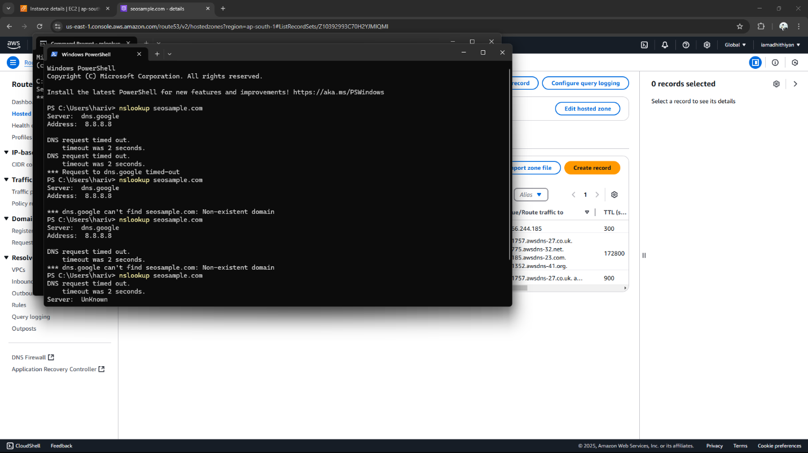

**Expected Outcome:**

1. Personalized Domain Accessibility

2. Enhanced User Experience & Brand Identity

3. Linking DNS to Web Application

4. Validation of DNS Setup